**Name: Merlin Moncy**

**Roll No:21**

**Batch:MCA-B**

**Date:04-04-2022**

**NETWORKING & SYSTEM ADMINISTRATION LAB**

**Experiment No.: 6**

**Aim**

Familarization of the linux commands

**Procedure**

1. **cp**

cp command is used to copy a file or a directory.

Syntax:

$cp sourcefile destinationfile

Output :

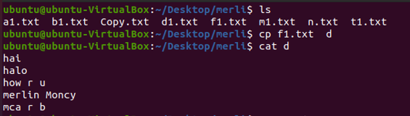

1. **cp –r**

To copy a directory along with its sub dirctories.

Syntax :

$cp -r sourcedirectory destinationdirectory

Output ;

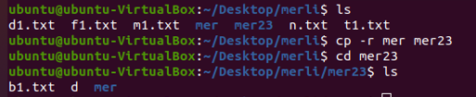

1. **cp -i**

The cp '-i' option allows you to confirm once before overwriting your file.

Syntax :

$cp -i filename directory

Output :

x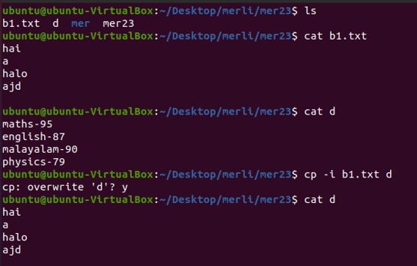

1. mv

**mv** stands for **move**. mv is used to move one or more files or directories from one place to another in a file system like UNIX. It has two distinct functions:   
**(i)** It renames a file or folder.   
**(ii)** It moves a group of files to a different directory.

Syntax :

$ mv sourcefile destinationfile

Output :

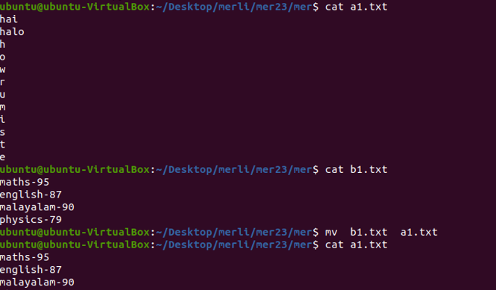

1. mv -i

The -i option makes the command ask the user for confirmation before moving a file that would overwrite an existing file

Syntax :

$mv -i sourcefile destinationdirectory

Output:

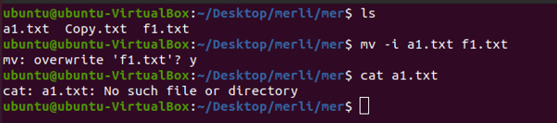

1. mv -f

The -f option overrides this minor protection and overwrites the destination file forcefully and deletes the source file.

Syntax :

$mv -f sourcefile destinationfile

Output ;

